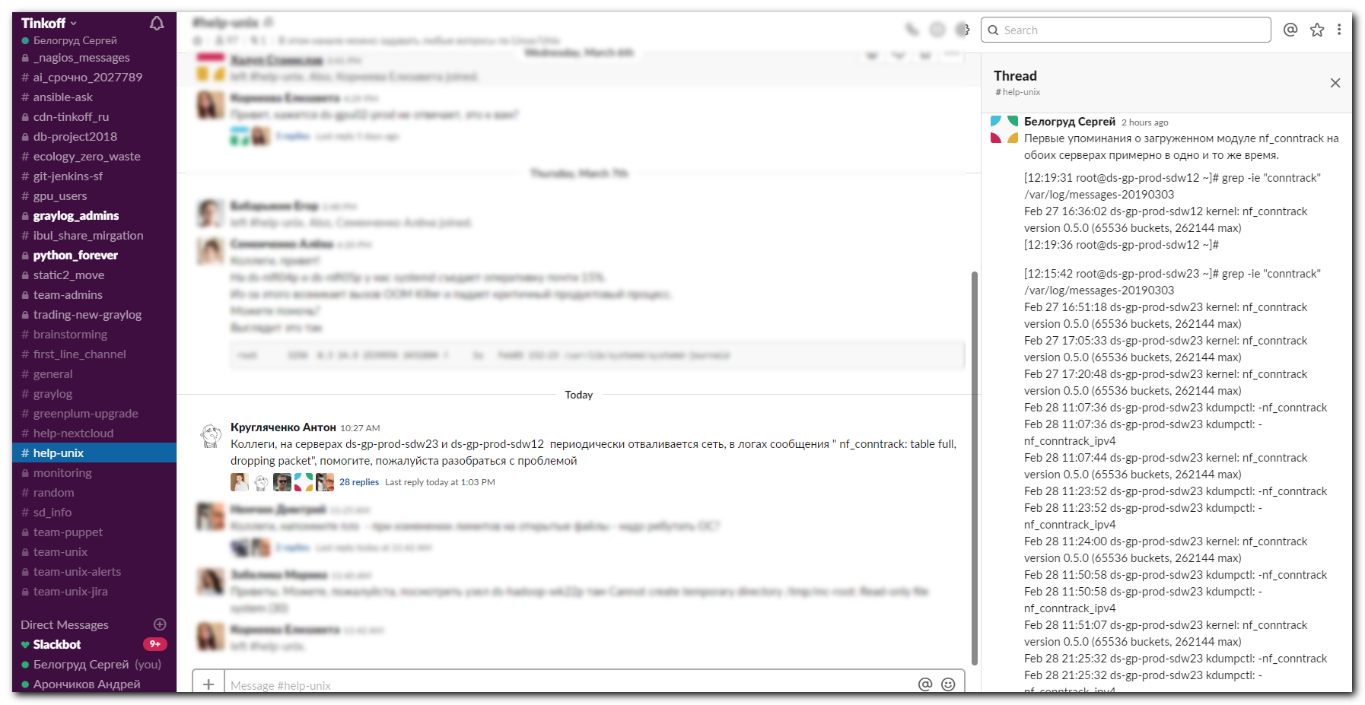
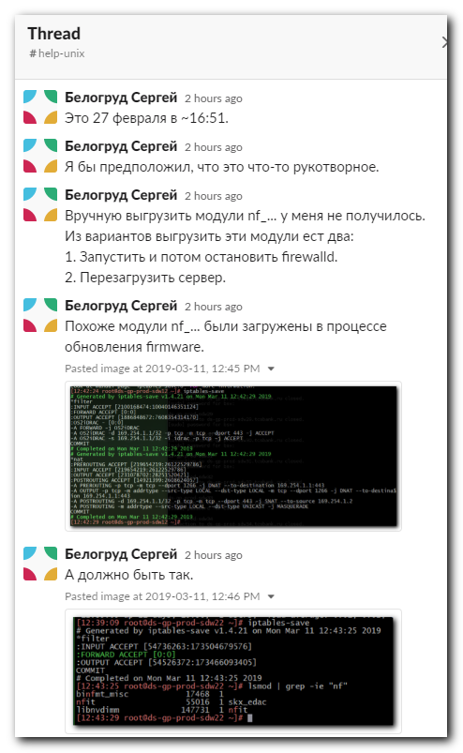
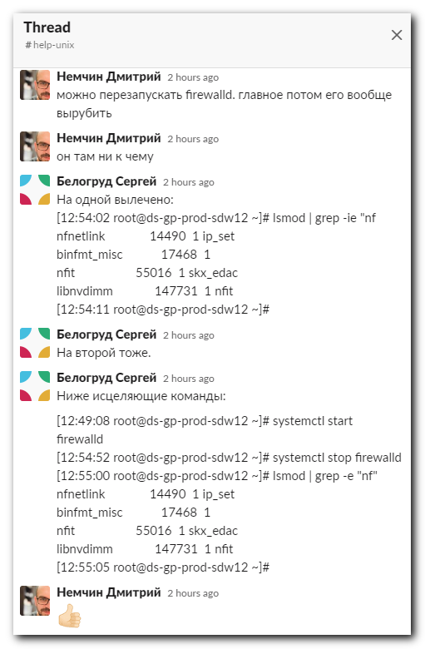

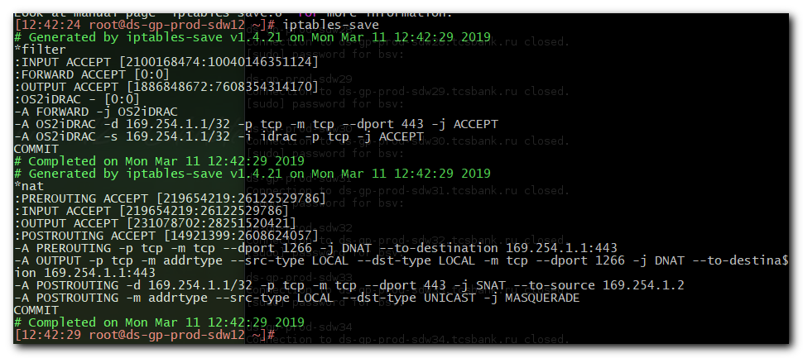
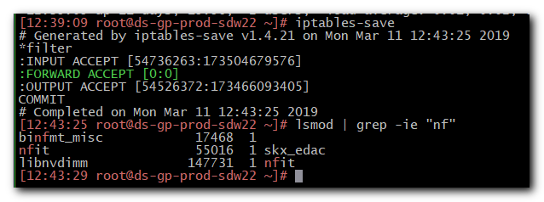

[11:39:57 root@ds-gp-prod-sdw12 ~]# lsmod | grep -e "nf"
nf_nat_masquerade_ipv4 13412 1 ipt_MASQUERADE
nf_conntrack_ipv4 15053 1
nf_defrag_ipv4 12729 1 nf_conntrack_ipv4
nf_nat_ipv4 14115 1 iptable_nat
nf_nat 26787 3 nf_nat_ipv4,xt_nat,nf_nat_masquerade_ipv4
nf_conntrack 133095 4 nf_nat,nf_nat_ipv4,nf_nat_masquerade_ipv4,nf_conntrack_ipv4
libcrc32c 12644 3 xfs,nf_nat,nf_conntrack
binfmt_misc 17468 1
nfit 55016 1 skx_edac
libnvdimm 147731 1 nfit
[11:40:04 root@ds-gp-prod-sdw12 ~]#

[12:15:42 root@ds-gp-prod-sdw23 ~]# grep -ie "conntrack" /var/log/messages-20190303
Feb 27 16:51:18 ds-gp-prod-sdw23 kernel: nf_conntrack version 0.5.0 (65536 buckets, 262144 max)
Feb 27 17:05:33 ds-gp-prod-sdw23 kernel: nf_conntrack version 0.5.0 (65536 buckets, 262144 max)
Feb 27 17:20:48 ds-gp-prod-sdw23 kernel: nf_conntrack version 0.5.0 (65536 buckets, 262144 max)
Feb 28 11:07:36 ds-gp-prod-sdw23 kdumpctl: -nf_conntrack
Feb 28 11:07:36 ds-gp-prod-sdw23 kdumpctl: -nf_conntrack_ipv4
Feb 28 11:07:44 ds-gp-prod-sdw23 kernel: nf_conntrack version 0.5.0 (65536 buckets, 262144 max)
Feb 28 11:23:52 ds-gp-prod-sdw23 kdumpctl: -nf_conntrack
Feb 28 11:23:52 ds-gp-prod-sdw23 kdumpctl: -nf_conntrack_ipv4
Feb 28 11:24:00 ds-gp-prod-sdw23 kernel: nf_conntrack version 0.5.0 (65536 buckets, 262144 max)
Feb 28 11:50:58 ds-gp-prod-sdw23 kdumpctl: -nf_conntrack
Feb 28 11:50:58 ds-gp-prod-sdw23 kdumpctl: -nf_conntrack_ipv4
Feb 28 11:51:07 ds-gp-prod-sdw23 kernel: nf_conntrack version 0.5.0 (65536 buckets, 262144 max)
Feb 28 21:25:32 ds-gp-prod-sdw23 kdumpctl: -nf_conntrack
Feb 28 21:25:32 ds-gp-prod-sdw23 kdumpctl: -nf_conntrack_ipv4
Feb 28 21:25:41 ds-gp-prod-sdw23 kernel: nf_conntrack version 0.5.0 (65536 buckets, 262144 max)
[12:15:54 root@ds-gp-prod-sdw23 ~]#

[12:19:31 root@ds-gp-prod-sdw12 ~]# grep -ie "conntrack" /var/log/messages-20190303
Feb 27 16:36:02 ds-gp-prod-sdw12 kernel: nf_conntrack version 0.5.0 (65536 buckets, 262144 max)
[12:19:36 root@ds-gp-prod-sdw12 ~]#

[12:42:24 root@ds-gp-prod-sdw12 ~]# iptables-save
# Generated by iptables-save v1.4.21 on Mon Mar 11 12:42:29 2019
*filter
:INPUT ACCEPT [2100168474:10040146351124]
:FORWARD ACCEPT [0:0]
:OUTPUT ACCEPT [1886848672:7608354314170]
:OS2iDRAC - [0:0]
-A FORWARD -j OS2iDRAC
-A OS2iDRAC -d 169.254.1.1/32 -p tcp -m tcp --dport 443 -j ACCEPT
-A OS2iDRAC -s 169.254.1.1/32 -i idrac -p tcp -j ACCEPT
COMMIT
# Completed on Mon Mar 11 12:42:29 2019
# Generated by iptables-save v1.4.21 on Mon Mar 11 12:42:29 2019
*nat
:PREROUTING ACCEPT [219654219:26122529786]
:INPUT ACCEPT [219654219:26122529786]
:OUTPUT ACCEPT [231078702:28251520421]
:POSTROUTING ACCEPT [14921399:2608624057]
-A PREROUTING -p tcp -m tcp --dport 1266 -j DNAT --to-destination 169.254.1.1:443
-A OUTPUT -p tcp -m addrtype --src-type LOCAL --dst-type LOCAL -m tcp --dport 1266 -j DNAT --to-destination 169.254.1.1:443
-A POSTROUTING -d 169.254.1.1/32 -p tcp -m tcp --dport 443 -j SNAT --to-source 169.254.1.2
-A POSTROUTING -m addrtype --src-type LOCAL --dst-type UNICAST -j MASQUERADE
COMMIT
# Completed on Mon Mar 11 12:42:29 2019
[12:42:29 root@ds-gp-prod-sdw12 ~]# systemctl start firewalld

#
# Here is a way, how fix it - remove modules cf_conntrack and similar.
#
[12:57:10 root@ds-gp-prod-sdw23 ~]# systemctl start firewalld
[12:57:16 root@ds-gp-prod-sdw23 ~]# systemctl stop firewalld
[12:57:23 root@ds-gp-prod-sdw23 ~]# lsmod | grep -e "nf"
nfnetlink 14490 1 ip_set
binfmt_misc 17468 1
nfit 55016 1 skx_edac
libnvdimm 147731 1 nfit
[12:57:31 root@ds-gp-prod-sdw23 ~]#
[12:57:32 root@ds-gp-prod-sdw23 ~]#

